
New Employee Onboarding Checklist
Customize the below new employee onboarding checklist to reflect the process you follow in your firm.

AT LEAST 1 WEEK BEFORE START DATE
- Office / work station set up
- Technology set up
  - Insert your technology here
- Employment forms are ready
- Create / update new employee training plan (see Training Plan Template)
- Create / update new employee training overview (see Training Overview)

AT LEAST 2 DAYS PRIOR TO START DATE
- Determine initial work assignments
- Create week 1 schedule (use sample editable calendar as found in Training Plan Overview resource)
  - Prepare and print orientation items
  - Ensure new employee’s schedule is synced with team members’ availability/calendars
  - Schedule weekly, 30-day, 60-day, 90-day and annual reviews with Manager
  - Ensure job description is reflective of work that will be completed
  - Collect necessary employment forms
  - Ensure employee manual / policies and procedures manual is ready to share
  - Firm materials (overview of firm, marketing materials, etc.) updated
- Schedule 1st week training items on existing team members’ calendars

FUTURE ITEMS
- Prepare and send new hire announcement
- Set up benefits enrollment

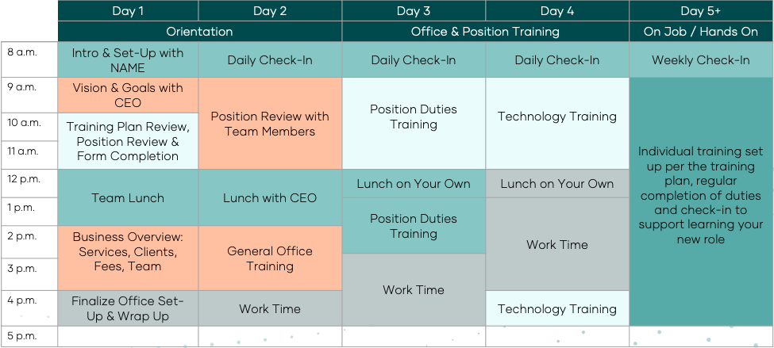
FIRST WEEK
DAY 1
  - Intro & office space set-up with team member
  - Vision & Goals overview with CEO; how their position is integral to the success of the firm
  - Meeting to review training plan and job description and set expectations for the role; include forms completion
  - Lunch with team members / CEO
  - Business Overview and Position Reviews, how each position is related, key processes related to services, clients, fees and team members
DAY 2
- Daily check-in with Manager, covering questions from day prior, agenda for the day, work that must be completed during training
- Position reviews with team members to understand related roles within the firm
- Lunch with the CEO
- General office training (phones, email, CRM system, etc.)
DAY 3
- Daily check-in with Manager, covering questions from prior day, agenda for the day, work that must be completed during training
- Position duties training, helpful if related to immediate and upcoming
- Work time
DAY 4
- Daily check-in with Manager, covering questions from prior day, agenda for the day, work that must be completed during training
- Technology training
- Lunch and work time
DAY 5
- Review of week and Training Plan including future weekly check-ins, 30, 60 and 90-day check-in dates, upcoming goals and trainings needed

