Client Review Process

The below is a sample best practice client review process. Editable Word® versions of the Forms referenced are available. When customizing your process, be sure to adjust the “by when” dates to align with how you time-block your client review meeting schedule.

Scheduling & COnfirmation: Initiate quarterly or
4-6 weeks pre-meetings
ACTION STEP |  | WHO | BY WHEN
1 | Run client review report and review with Adviser to confirm clients that are due for a client review  Best Practice: Client meeting preparation and case prep meetings should be large blocks of time to prepare for client meeting blocks. | CSA | 1st week of each quarter
2 | Personalize and send Form 1: Client Review Scheduling Email to clients due for a client review | CSA | 1st week of each quarter
3 | Update Client Review list weekly to ensure all reviews are scheduled  For clients who do not respond by the end of the first month in the quarter, send follow-up email (Form 2: Client Review Non-responders) | CSA | Weekly
4 | Schedule or confirm time is blocked for the following tasks and meetings:  Adviser and team preparation time blocks  Client Review Preparation Meeting  Client Review Follow Up Meeting | CSA | 2nd week of each quarter
5 | Upon scheduling, an automated email (Form 3: Client Review Confirmation Email) is sent to the client. | CSA | Upon meeting scheduling

preparation: Initiate 3 weeks prior to client reviews
ACTION STEP |  | WHO | BY WHEN
1 | Send confirmation and request for information email  (Form 4: Client Info Request Email) to client | CSA | 3 weeks prior to review
2 | Compile client review materials (Form 5: Client Review Checklist, Form 6: Client Meeting Agenda) | TEAM | 2 weeks prior to meeting(s)
3 | Completes review of client meeting materials and determines recommendations | ADV | 1.5 weeks prior to meeting(s)
4 | Client Review Prep Meeting is held to review client experience (Form 7: Client Review Journey) and finalize preparation needs (Form 8: Case Prep Meeting Agenda) | TEAM | 1.5 weeks prior to meeting(s)
5 | Team makes final updates to client meeting materials | TEAM | 1 week prior to meeting(s)
6 | Send final meeting agenda to client (FORM 9: Client Agenda Email) | ADV | 5 days prior to meeting(s)

client review: Day of
ACTION STEP |  |  | WHO |  | BY WHEN
1 | Office is prepared for client meetings on Client Meeting Days | TEAM |  | Morning Of
2 | Client receives personalized welcome at the door and is offered refreshments | CSA / Team |  | At Meeting Time
3 | Meeting is held; action items and any client information/intel are dictated / captured for the team  Best Practice: Leveraging Adviser Time is critical – if possible, have an Associate Adviser / Paraplanner / Asst. attend the meeting to capture notes and provide ongoing training. | ADV / Client |  | At Meeting

Follow-up: within 48 hours post
ACTION STEP |  |  |  | WHO |  | BY WHEN
1 |  | Action items are reviewed and input into CRM system along with any client intel that was captured |  | CSA |  | Within 48 hours of the meeting
2 | Form 10: Review Follow-Up Email is sent to the client summarizing action items from the meeting  Implementation Note: If you use another form of follow-up, such as a shared task system be sure to customize this step to address how you share actions items with clients. |  | CSA |  | Within 48 hours of the meeting
3 |  | Hold follow-up team meeting to review:  What went well, what didn’t  What needs to be fixed for next time  Important action items and follow ups  Implementation Note: If the team has mastered this process or you have review meetings more frequently, you may want to reduce the frequency of this meeting. |  | TEAM |  | 1 week post meetings

Client Review Process Resources
The below are the available samples you can customize to finalize your strategic review process. Editable versions are available in Word®.

CLIENT PROCESS FORMS
Form 1: Client Review Scheduling Email
Form 2: Client Review Non-Responders
Form 3: Client Review Confirmation Email
Form 4: Client Info Request Email
Form 5: Client Review Checklist

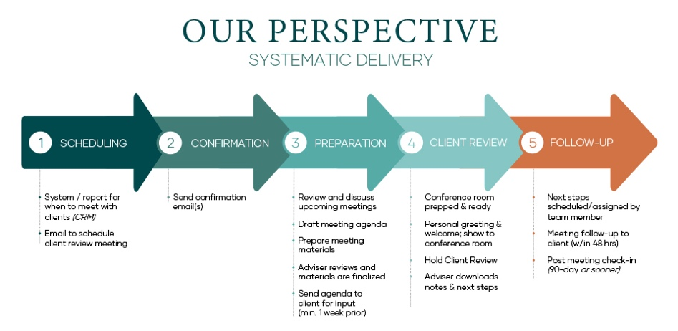
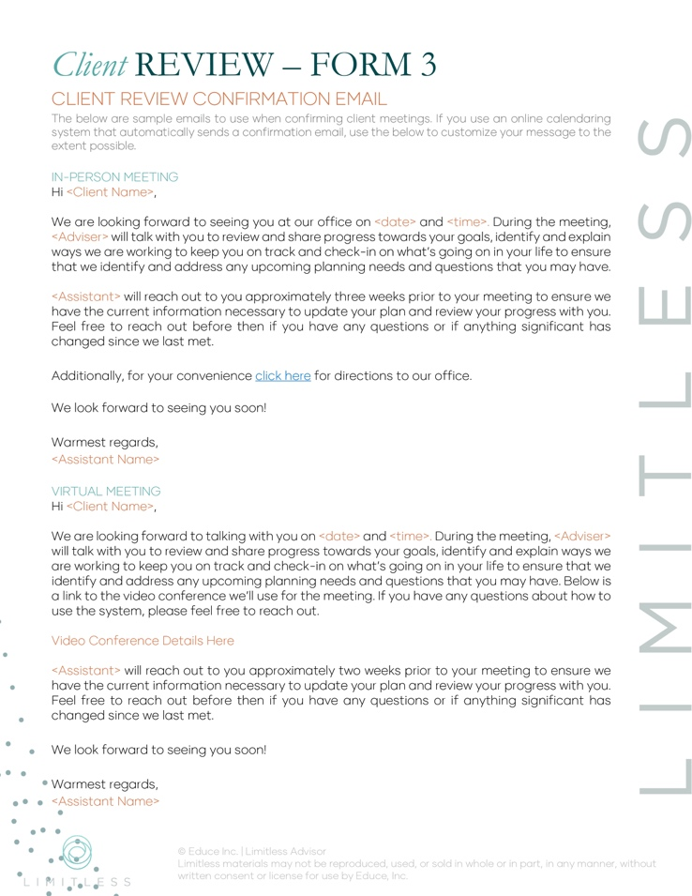
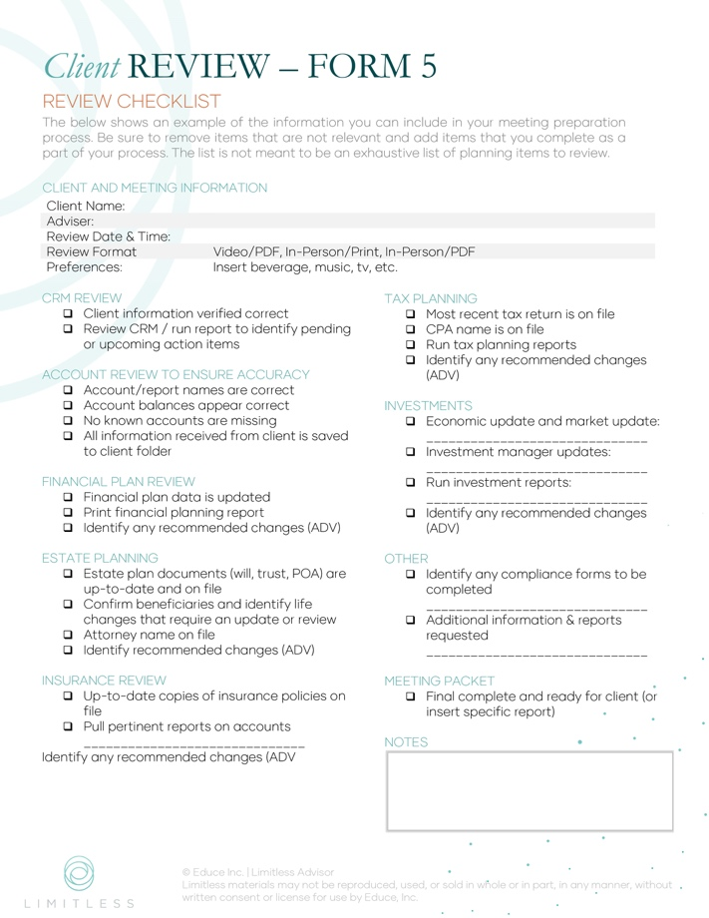
Form 6: Client Review Agenda
Form 7: Client Review Journey
Form 8: Case Prep Meeting Agenda
Form 9: Client Meeting Agenda Email
Form 10: Review Follow-Up Email

