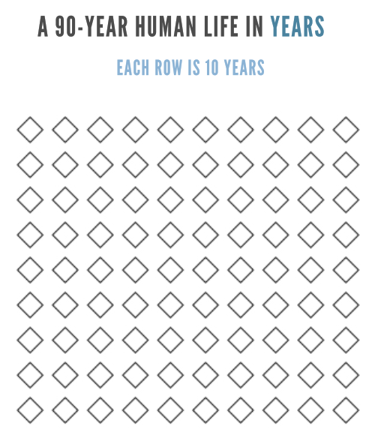



Property of Seth Streeter and Mission Wealth, not to be duplicated, copied or shared without permission.

